ANATOMY OF THE FACIAL NERVE
- Intra-cranial part:
Within the intra-cranial cavity.
Fibers form the facial nucleus in the pons pass around the nucleus of the 6th cranial (abducent) nerve emerges from the pons => crosses the cerebello-pontine angle with the VIII cranial (cochleo-vestibular) nerve then enters the internal auditory canal.
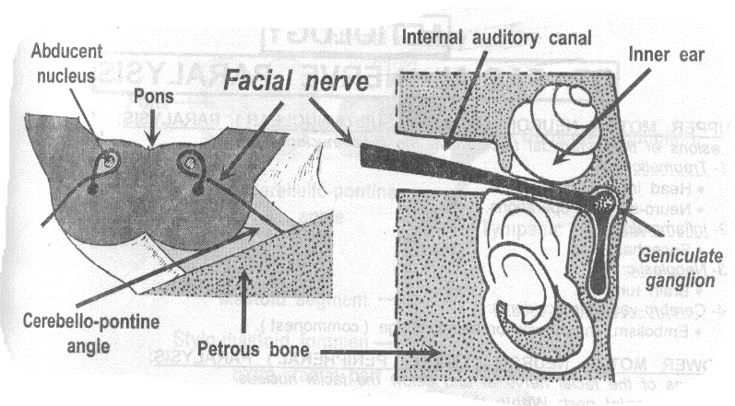
- Cranial part: Within the temporal bone.
  - Sugrageniculate segment:
The nerve passes through the IAC then runs above the inner ear then reaches the medial wall of the middle ear, where it forms the geniculate ganglion
At the ganglion, it gives one branch which is the Greater superficial petrosal nerve => secretory to the lacrimal gland & the nasal and palatine sero-mucinous glands.
  - Tympanic (horizontal) segment:
At the geniculate ganglion, the nerve turns (forming the first genu) Then runs horizontally backwards in the medial wall of the middle ear above the promontory and oval window.
  - Mastoid (vertical) segment:
When the nerve reaches the posterior wall of the middle ear, it turns (forming the second genu). Then runs vertically downwards in the posterior wall of the middle ear. This segment gives two branches;
Nerve to stapedius muscle => motor to the stapedius muscle and
Chorda tympani nerve => taste from the anterior 2/3 of the tongue & secretory to the submandibular and sublingual salivary glands.
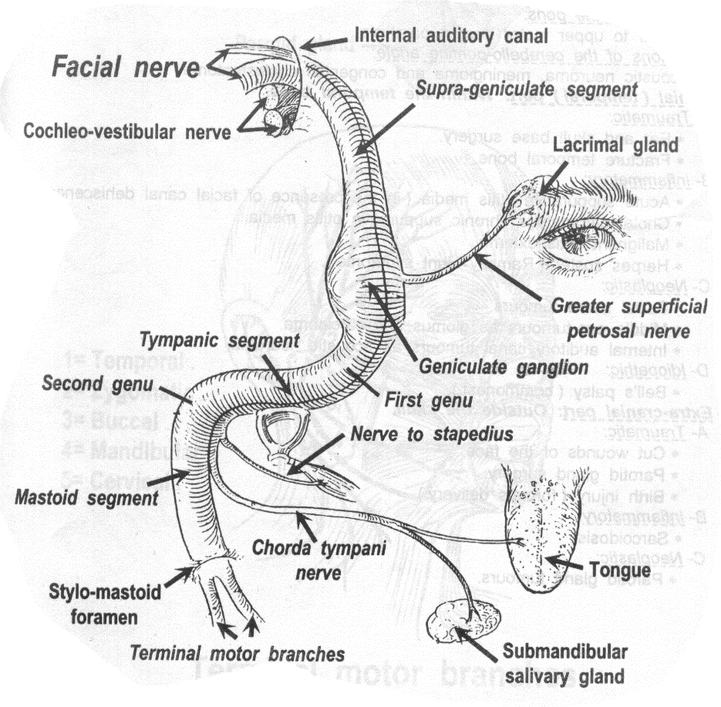
- Extra-cranial part: Outside the skull.
The nerve emerges from the skull through the stylomastoid foramen giving motor branches to the stylohyoid and posterior belly of digastric muscles then enters the parotid gland to divide into five terminal motor branches => Temporal, zygomatic, buccal, mandibular and cervical branches (motor to muscles of facial expressions).

